Lecture 2: Query Tuning

2.1 Methods

- Eliminating redundant DISTINCT
- Rewriting nested queries

2.2 Relational Algebra

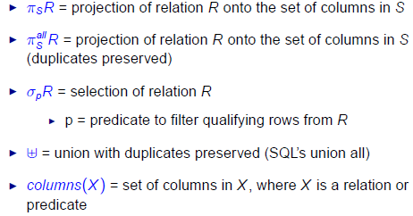

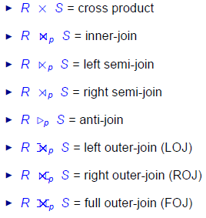
2.2 Functional Dependencies
- Functional Dependencies (FDs) are constraints on schemas that specify that the values for a certain set of attributes determine unique values for another set of attributes
- Let a and b denotes subsets of attributes of a relational schema R (i.e. a, b [ columns ( R )]
- We use a → b to denote that a functionally determines b (or B functionally depends on a)
- Let πα(t) denote the projection of α on tuple t
- Let r be a relation instance of relation schema R
- r satisfies FD α → β if for every pair of tuples t1 and t2 in r such that πα(t1) = πα(t2), it is also true that πβ(t1) = πβ(t2)
- A FD α → β holds on R iff for any relation instance r of R, r satisfies α → β

- A set of attributes α is a superkey of schema R if for every instance r of R, r has no duplicate values for α
- α is a superkey of R iff α → columns(R)

- α is a key of R if α is a superkey of R and no proper subset of α is a superkey of R

Review: Reasoning about FDs
- Let F be a set of FDs and f be an FD
- F logically implies (or implies) f if every relation instance of R that satisfies the FDs F also satisfies the FD f

Inference Rules for FDs
- Let α, β, γ subset of columns(R)
  - Reflexivity: If β subset of α, then α → β
  - Augmentation: If α → β, then αγ → βγ
  - Transitivity: If α → β and β → γ, then α → γ
  - Union: If α → β and α → γ, then α → βγ
  - Decomposition: If α → β, then α → β′ for any β′ subset β

- Let α be the subsets of columns(R)

- Let F be a set of FDs that hold on R

- The closure of α (with respect to F), denoted by α+, is the set of attributes that are functionally determined by α with respect to F
  - α+ = {A subset of columns(R) | F implies α → A}
  - paraphrase, given 1 set of columns α, what columns can this α determine

- F implies α → β if and only if β subset of α+ (w.r.t. F)

Input: α, F
Output: α+ (w.r.t. F)
α+ = α
stop = false
repeat
if (there exists some FD β → γ ∈ F such that β ⊆ α+ and γ 6∈ α+) then
α+ = α+ ∪ γ
else
stop = true
until (stop)
return α+
2.3 Eliminating Redundant Distinct

- SPJ (Select Project and Join) Queries

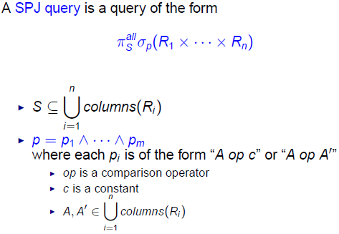
Lecture 3: Query Tuning (Part 2)

3.1 Reordering Group by & Select

- Customer (cust#, cname, country)
- Order (order#, cust#, date, totalprice)

  - select cust # , date , t o t a l
from (
select cust # , date , sum( t o t a l p r i c e ) as t o t a l
from Order
group by cust # , date
)
where date >= '2013−01−01 '

  - select cust # , date , sum( t o t a l p r i c e ) as t o t a l
from Order
where date >= '2013−01−01 '
group by cust # , date

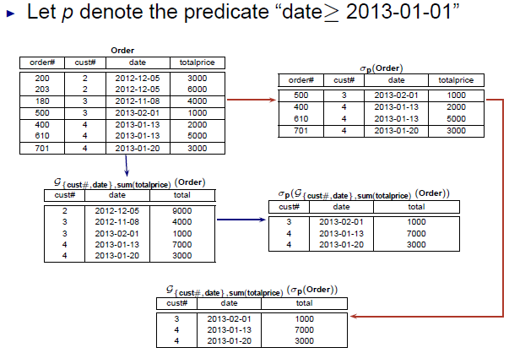

It is possible to reorder group by as follow:

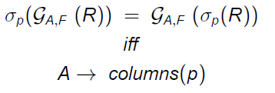
3.2 Pushing Group By Below Join

- Customer (cust#, cname, country)
- Order (order#, cust#, date, totalprice)

  - select c . cust # , cname , sum( o . t o t a l p r i c e ) as T
from Customer c join Order o
on c . cust# = o . cust#
group by c . cust # , cname

  - select c . cust # , cname , T
from customer c ,
(
select cust # , sum( t o t a l p r i c e ) as T
from Order
group by cust#
) as o
where c . cust# = o . cust#

- Example 1:

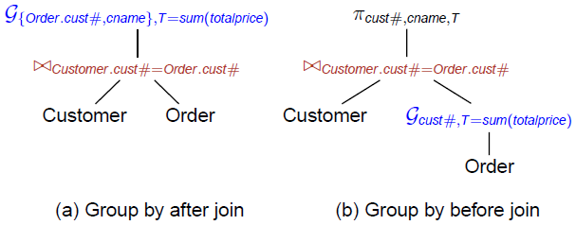

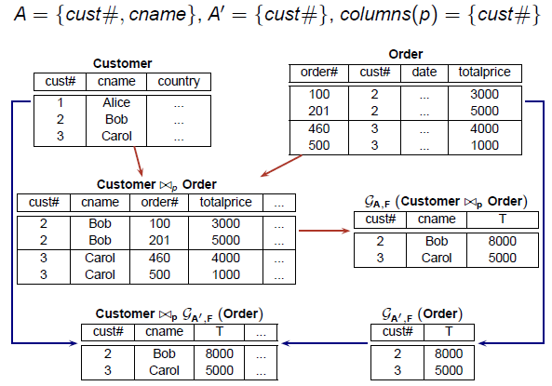
- Example 2

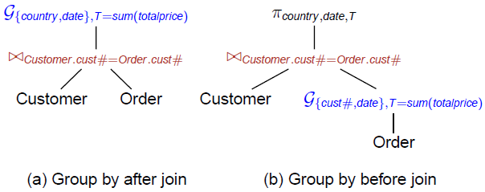

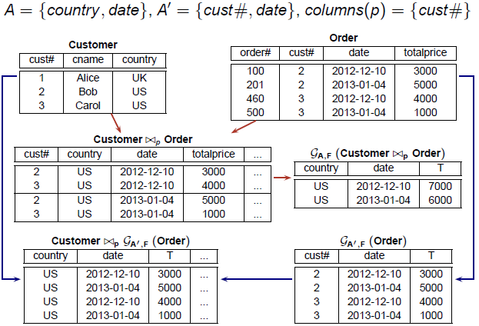

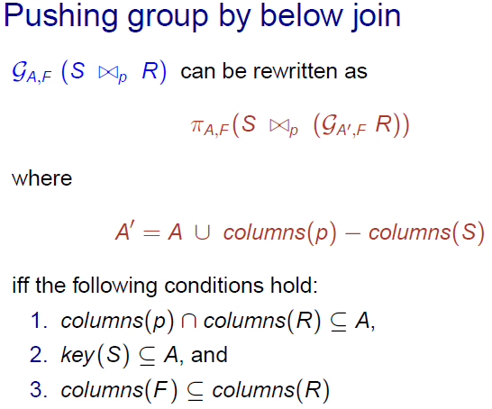
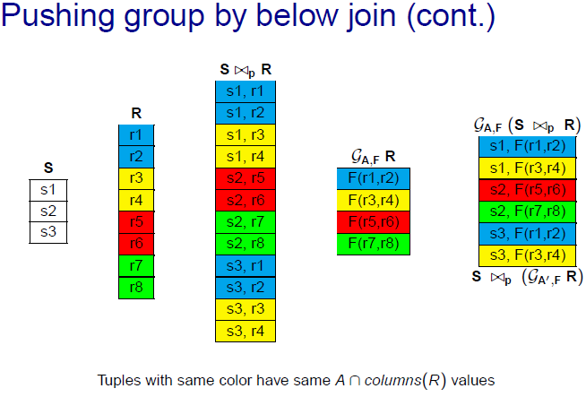

- Rewriting Example 1:

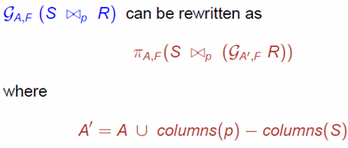

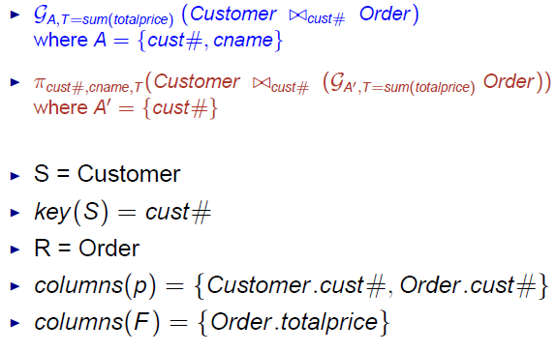
- Rewriting Example 2:

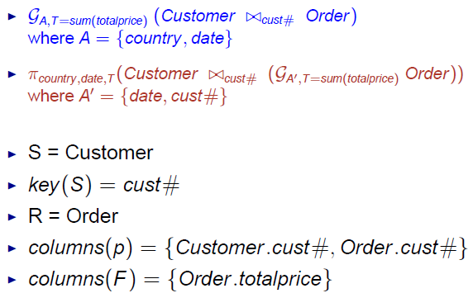

3.3 Pulling group by above join

- Customer (cust#, cname, country)
- Order (order#, cust#, date, totalprice)

  - select c . cust # , cname , count ry , date , T
from customer c ,
( select cust # , date , sum( t o t a l p r i c e ) as T
from Order
group by cust # , date
) as o
where c . cust# = o . cust#

  - select c . cust # , cname , country , date ,
sum( o . t o t a l p r i c e ) as T
from Customer c join Order o
on c . cust# = o . cust#
group by c . cust # , cname , country , date

- Example 3:

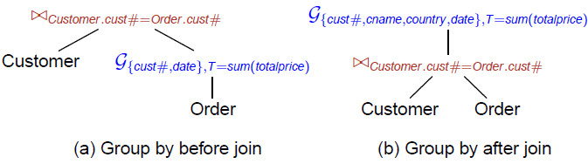

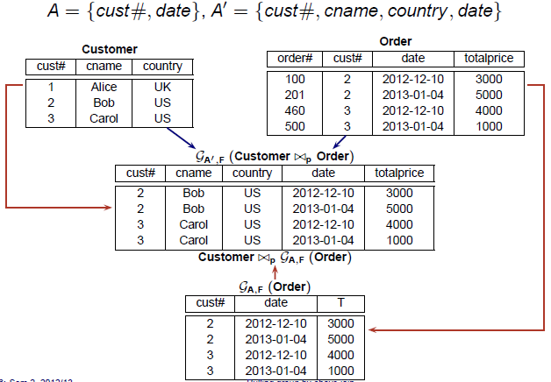

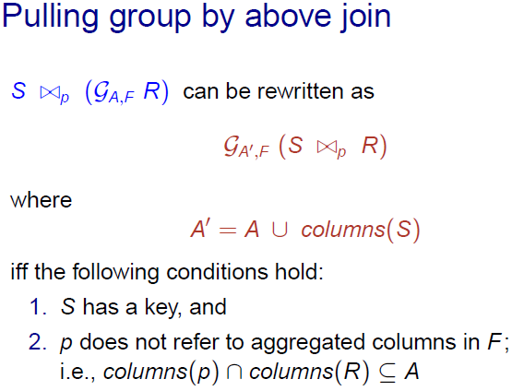
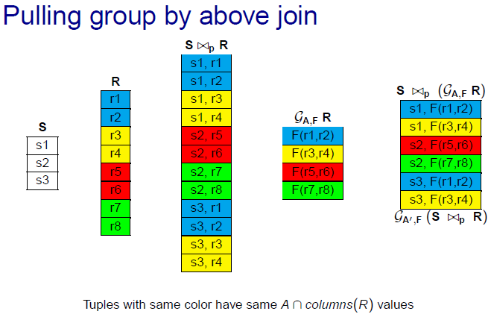

CS5226 Lecture 5 - Materialized Views Tuning

- Given a view V and a query Q, V subsumes Q if
  - V contains at least all the tuples required in Q, and
  - it is possible to filter out the irrevalent tuples from V
- If a view V subsumes a query Q, then V can be used to answer Q

select S1, S2, · · · – projection columns
from T1, T2, · · · – tables
where J1 and J2 and · · · – equi-join predicates
R1 and R2 and · · · – range predicates
Z1 and Z2 and · · · – residual predicates
group by G1, G2, · · · – grouping columns

- Each range predicate is a disjunction of open/closed intervals over same column
- Example:

- Materialized view denoted by V = (S, T, J, R, Z,G)
  - S = set of columns in the select clause
  - T = set of tables
  - J = set of join predicates
  - R = set of range predicates
  - Z = set of residual predicates (A residual predicate is one that has an hidden extra cost because the predicate has to be tested again on every combination of rows that is fetched.)
  - G = set of grouping columns
Lecture 8: Transaction Tuning 2 (Snapshot Isolation)

8.1 Multiversion Concurrency Control (MVCC)
- Motivation : Increase concurrency
- Key Idea: maintain multiple versions of each object
- W (O) creates a new version of object O
- R (O) reads the most recent version of O that is created by a committed Xact
- Advantages
- Readers are not blocked by writers
- Readers do not block writers
- Read-only Xacts are never aborted
- MVCC Techniques
- Multiversion 2phase locking
- Multiversion timestamp ordering
- Snapshot isolation

8.2 Snapshot Isolation
- Widely used by (e.g. Oracle, SQL server etc)
- Each Xact T sees a snapshot of the DB that consists of updates by Xacts that committed before T starts
- Each Xact T is associated with 2 timestamps
- Start(T): the time that T starts
- Commit(T): the time that T commits
- 2 Xact are defined to be concurrent if their start/commit time overlaps each other
- Example
- Wi(O) creates a version of O denoted by Oi
- Ri(O) reads the latest version of O that is created by a Xact that committed before Ti started;
i.e., If Ri(O) returns Oj , then
1. commit(T_{j}) < start(T_{i}), and
2. For every Xact T_{k} , k 6= j, that has created a version Ok of
O, if commit(T_{k} ) < start(T_{i}), then commit(T_{k} ) < commit(T_{j})
Note: if T_{i} has updated O, then any R_{i}(O) following Wi(O) will read O_{i}
- Tradeoff
- Performance often similat ro read committed
- Does not suffer from lost update or unrepeatable read anomalies
- But vulnerable to some non-serializable execution
  - Write skew anomaly
  - Read-Only Transaction Anomaly

8.3 First Committer Wins Rule
- If two concurrent Xacts update the same object, only one of them can commit
- First Committer Wins (FCW) Rule:
  - Before commiting a Xact T, the system checks if there exists a committed concurrent Xact T′ that has updated some object that T intends to update
  - If T¹ exists, then T aborts
  - Otherwise, T commits with its updates written to the database

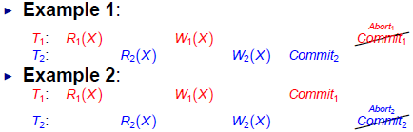
8.4 First Updater Wins Rule
- Some implementations use write locks to prevent concurrent updates to same objects
- FCW rule becomes First Updater Wins (FUW) Rule
- First Updater Wins Rule:
  - Before a Xact T can update an object O, T needs to request for a write lock on O
  - If another Xact is holding a write lock on O, T is blocked
  - When T’s lock request on O is granted, the system checks if some other committed concurrent Xact has updated O
  - If so, T aborts
  - Otherwise, T updates O and proceeds with its execution

8.5 Transactional Dependencies
- ww dependency from T1 to T2
  - T1 writes a version of some data item x, and
  - T2 later writes the immediate successor version of x
- wr dependency from T1 to T2
  - T1 writes a version of some data item x, and
  - T2 reads this version of x
- rw dependency from T1 to T2
  - T1 reads a version or some data item x, and
  - T2 later creates the immediate successor version of x

The above definitions assume data item reads/writes & can be generalized for predicate reads/writes

8.6 Dependency Serialization Graph
- Consider a schedule S consisting of a set of committed transactions {T1, · · · , Tk}
- DSG(S) is an edge-labelled directed graph (V, E)
- V represents transactions {T1, · · · , Tk}
- E represents transactional dependencies
  - Ti (ww)→ Tj
  - Ti (wr) → Tj
  - Ti (rw) →Tj
- Edge types:
  - if transaction pair is concurrent
  - if transaction pair is non-concurrent
- Example
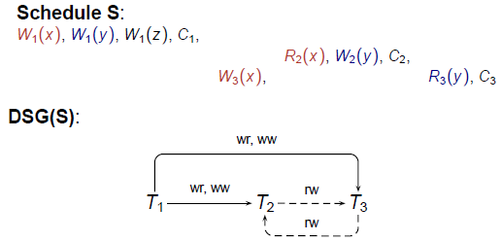

8.7 Non-Serializable SI Schedules
- Theorem 1: If S is a non-serializable SI schedule, then
  - 1. There is at least one cycle in DSG(S), and
  - 2. For each cycle in DSG(S), there exists three transactions, T_{in}, T_{pivot} , and T_{out} such that
    - T_{in} & T_{out} are possibly the same transaction,
    - T_{in} & T_{pivot} are concurrent with an edge T_{in} (rw) →T_{pivot} , and
    - T_{pivot} & T_{out} are concurrent with an edge T_{pivot} (rw) → T_{out} .

First Example is Skew Anomaly, Second is a Read-only Xact anomaly
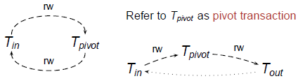
- Theorem 2: If an application A has a static dependency graph SDG(A) with no dangerous structure, then A is serializable under SI

8.8 Static Dependency

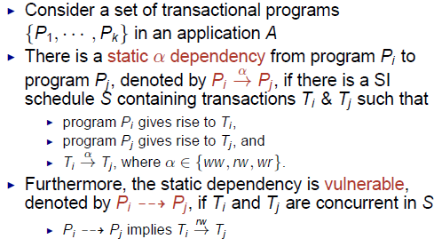

Static Dependency Graph (SDG)

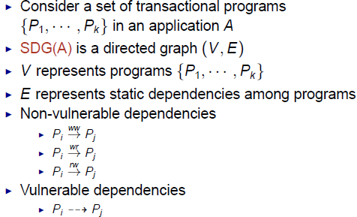

Dangerous Structures

